IMPLICIT WAITS

What it is:
- A global timer set once per session
- Applies to ALL find_element calls
- If element not found immediately, waits up to X seconds

How it works:
- Polls DOM repeatedly: Checks webpage constantly until element found
- Default polling frequency: Usually checks every 0.5 seconds

Syntax
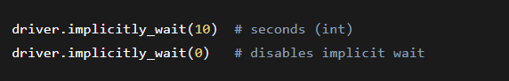
For time = 10, it checks if an element exists right when the page loads, if it doesn’t then it it constantly checks for its existance for 10 secs.
In case of time = 0, if an element doesn’t exist right when the page loads, till will result failure case

When to use time =0?
- When you want immediate failure if element missing
- When switching between different wait strategies
- For performance in scripts where you know elements load instantly

Important:
- Set only once at start
- Doesn't care about element state (just presence is required and checked)
- First parameter in find_element is search method, second is value

To Search An Element
find_element("how", "what")
Finds ONE element on the page (in the examples case, button in the html file and stores in button variable).
"how" = Search method (id, name, class, tag, etc.) (These WON’T be defined by user as they will be HTML tags, look at below given valid options)
"what" = Value to search for
Example: find_element("id", "username") = "Find the element with id='username'"

